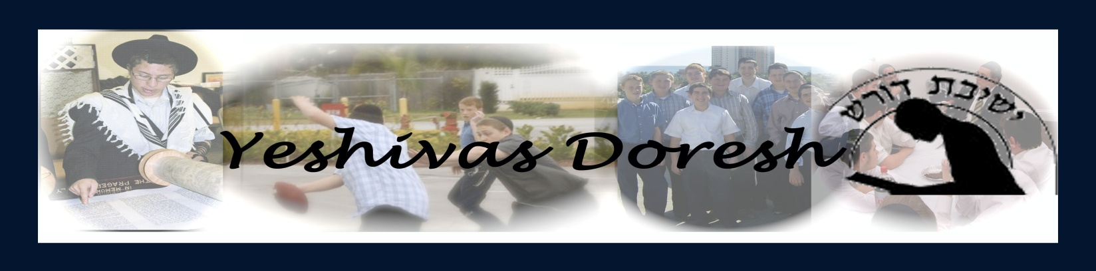
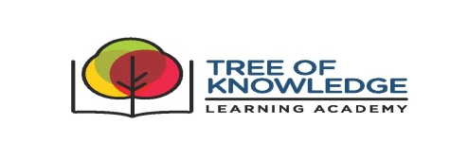
Yeshiva Doresh/Tree of Knowledge 2016-2017 Calendar

School Opens:
Wednesday Night, September 7th at 7:30 PM for supper; followed by Orientation and Contract Signing at 8:00 PM

Home Break:
Thursday, October 6th after 9:30 AM

Return to School After the Succos Holidays:
Tuesday, November 1th for supper

Channukah Break:
Thursday, December 22st after 9:30 AM

Return from Channukah Break:
Tuesday January 3rd for supper

Spring Break:
Tuesday, April 4th after 9:30 AM

Return:
Wednesday, April 26th for supper

Yeshiva Doresh/Tree of Knowledge Scholarship Event, Graduation:
Sunday morning, June 11th at 11:00 AM TENTATIVE DATE
Parents are invited for an optional Shabbaton (27th-28th) with the Yeshiva

School Ends:
Wednesday, June 13th, after 9 AM

Optional Summer Camp:
Details will follow.

